Partial Mesh

What Is Partial Mesh?
# Source: AI Source: Provided by: [Data Path: Persons Table -> ID Column: 1, Name_En Column: Motasem Essam] -> From: [ChatGPT] on [12/18/2025]
A Partial Mesh Topology is a type of mesh network where only some devices are directly connected to each other, not all. It balances between the redundancy of full mesh and the efficiency of simpler topologies like star or bus.

🧠 Simple Definition:
# Source: AI Source: Provided by: [Data Path: Persons Table -> ID Column: 1, Name_En Column: Motasem Essam] -> From: [ChatGPT] on [12/18/2025]
In a partial mesh, some nodes have dedicated links, while others connect through intermediate devices, providing selective redundancy and cost savings.

🖼️ Visual Example:
# Source: AI Source: Provided by: [Data Path: Persons Table -> ID Column: 1, Name_En Column: Motasem Essam] -> From: [ChatGPT] on [12/18/2025]
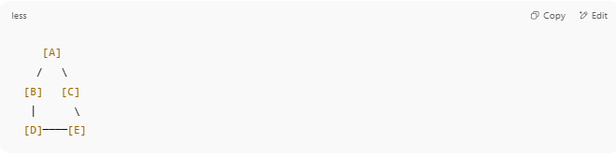
[A]
/ \
[B] [C]
| \
[D]────[E]

- Devices A, B, and C aren't fully connected.
- But D and E have an extra link for reliability.
- Not every node connects to every other node directly.

🔁 How It Works
# Source: AI Source: Provided by: [Data Path: Persons Table -> ID Column: 1, Name_En Column: Motasem Essam] -> From: [ChatGPT] on [12/18/2025]
- Key nodes (like servers or routers) may have multiple direct links.
- Less critical nodes may have only one or two.
- Offers backup paths without the full cabling burden of full mesh.

✅ Advantages
# Source: AI Source: Provided by: [Data Path: Persons Table -> ID Column: 1, Name_En Column: Motasem Essam] -> From: [ChatGPT] on [12/18/2025]
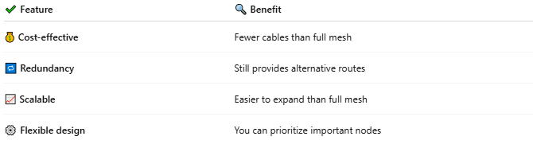

✔ Feature | 🔍 Benefit
💰 Cost-effective | Fewer cables than full mesh
🔁 Redundancy | Still provides alternative routes
📈 Scalable | Easier to expand than full mesh
⚙️ Flexible design | You can prioritize important nodes

❌ Disadvantages
# Source: AI Source: Provided by: [Data Path: Persons Table -> ID Column: 1, Name_En Column: Motasem Essam] -> From: [ChatGPT] on [12/18/2025]
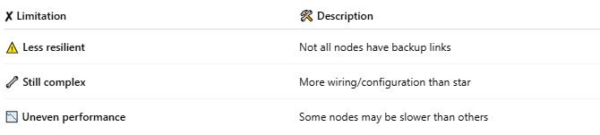

✘ Limitation | 🛠 Description
⚠️ Less resilient | Not all nodes have backup links
🔧 Still complex | More wiring/configuration than star
📉 Uneven performance | Some nodes may be slower than others

🛠 Use Cases
# Source: AI Source: Provided by: [Data Path: Persons Table -> ID Column: 1, Name_En Column: Motasem Essam] -> From: [ChatGPT] on [12/18/2025]
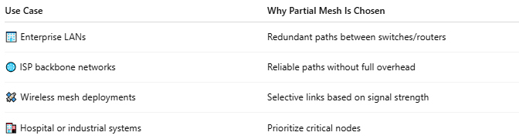

Use Case | Why Partial Mesh Is Chosen
🏢 Enterprise LANs | Redundant paths between switches/routers
🌐 ISP backbone networks | Reliable paths without full overhead
🛰️ Wireless mesh deployments | Selective links based on signal strength
🏥 Hospital or industrial systems | Prioritize critical nodes

🔢 Comparison: Full Mesh vs Partial Mesh
# Source: AI Source: Provided by: [Data Path: Persons Table -> ID Column: 1, Name_En Column: Motasem Essam] -> From: [ChatGPT] on [12/18/2025]
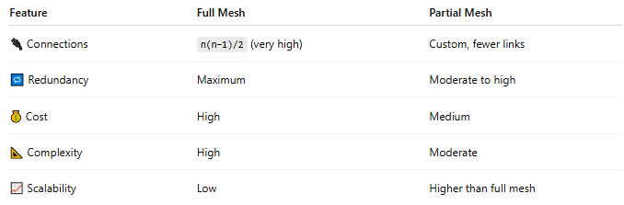

Feature | Full Mesh | Partial Mesh
🔌 Connections | n(n−1)/2 (very high) | Custom, fewer links
🔁 Redundancy | Maximum | Moderate to high
💰 Cost | High | Medium
📐 Complexity | High | Moderate
📈 Scalability | Low | Higher than full mesh

✅ Summary
# Source: AI Source: Provided by: [Data Path: Persons Table -> ID Column: 1, Name_En Column: Motasem Essam] -> From: [ChatGPT] on [12/18/2025]
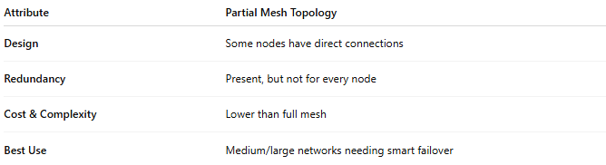

Attribute | Partial Mesh Topology
Design | Some nodes have direct connections
Redundancy | Present, but not for every node
Cost & Complexity | Lower than full mesh
Best Use | Medium/large networks needing smart failover

